**BRAIN TUMOR DETECTION AND CLASSIFICATION USING MULTIPLE DEEP LEARNING TECHNIQUES**

Selva Karthik, Achuthan, Dr Dennis Ananth

**ABSTRACT** A brain tumor is an abnormal growth or mass of cells in or around your brain. Early detection of brain tumors is imperative, impacting the quality of life and potential fatality. Extended undetected brain tumours can cause irreversible brain damage. Early detection allows doctors to intervene before severe harm, preserving cognitive function and reducing permanent damage risk [44]. These tumors come in a wide variety of sizes, textures, and locations. When trying to locate cancerous tumors, magnetic resonance imaging (MRI) is a crucial tool. However, detecting brain tumors manually is a difficult and time-consuming activity that might lead to inaccuracies. Many researchers investigated a variety of algorithms for detecting and classifying brain tumors that were both accurate and fast. Deep Learning (DL) approaches have recently been popular in developing automated systems capable of accurately diagnosing or segmenting various tumors in less time [47]. Using computational intelligence and statistical image processing techniques, this research paper proposed several ways to detect brain cancer and tumors. In this study, three different deep learning architecture models along with Data Augmentation and Image Processing to categorize brain MRI scan images into cancerous and non-cancerous. We later conducted a comparative analysis of our models: EfficientNetB4, Vision Transformer (ViT) combined with EfficientNetB4 (a noval hybrid model) and a custom CNN model build from scratch. The experiment results demonstrates that all models achieved high accuracy and very low complexity rate. Specifically, EfficientNetB4 achieving 99.76%, 99.6% in Vision Transformer + EfficientNetB4 and scratch CNN achieved 92.77% accuracy. Our models require very less computational power and has much better accuracy results as compared to other pre-trained models.

**Keywords** *Brain tumor detection; MRI Classification; EfficientNetB4; Vision Transformer (ViT); CNN (Convolution Neural Network)*



1. **INTRODUCTION**

A brain tumor is a growth of cells in the brain or near it. Brain tumors can happen in the brain tissue and nearby. Nearby locations include nerves, the pituitary gland, the pineal gland, and the membranes that cover the surface of the brain. Brain tumors can begin in the brain. These are called primary brain tumors. Sometimes, cancer spreads to the brain from other parts of the body. These tumors are secondary brain tumors, also called metastatic brain tumors.

Many different types of primary brain tumors exist. Some brain tumors aren't cancerous. These are called noncancerous brain tumors or benign brain tumors. Noncancerous brain tumors may grow over time and press on the brain tissue. Other brain tumors are brain cancers, also called malignant brain tumors. Brain cancers may grow quickly. The cancer cells can invade and destroy the brain tissue. Brain tumor treatment options depend on the type of brain tumor you have, as well as its size and location. Common treatments include surgery and radiation therapy. There are two types of brain tumors:

**Malignant Brain tumors:** Gliomas and related brain tumors, Embryonal, Germ cell, Pineal tumors.

**Benign Brain tumors:** Choroid plexus, Meningiomas, Pituitary Nerve tumors [45].

With over 300,000 cases reported annually on a worldwide basis, brain tumors are consistently pressing concern for the international medical community. While some brain tumors may be benign, many can invade the normal brain and develop into brain cancer Approximately 72% of all brain tumors are benign and 28% of all brain tumors are malignant. An estimated 67,440 will be non-malignant (benign) in 2024. Non-malignant meningiomas are the most commonly occurring primary non-malignant brain tumors, accounting for 39.7% of all tumors and 55.4% of all non-malignant tumors. Glioblastoma is the most commonly occurring primary malignant brain tumor, accounting for 14.2% of all tumors and 50.1% of all malignant tumors.

Magnetic resonance imaging (MRI) and biopsy are routinely performed for the diagnosis of intracranial tumors, with biopsy considered a criterion standard for the classification of tumor types. Although a standard practice, biopsy has associated challenges because it is invasive. Therefore, identification and accurate classification of tumor subtypes from non-invasive methods like MRI are desired. However, distinguishing different types of tumors from MRI images can be challenging due to the similarities in tumor appearance on scans. Therefore, an accurate, reliable preoperative determination of tumor types from MRI may facilitate rapid clinical decision-making and aid in better treatment planning [46].

Deep learning is often used in healthcare for analysis, classification, and detection. The processing capability of CNN is derived from a computational model inspired by the structure and functioning of the human brain. Humans can see and identify things by relying on their external visual characteristics. The CNN, known for its proficiency in image processing, operates similarly. Several well-recognized CNN models include Res Net, Goog LeNet, Alex Net, and VGG. Recently, deep learning has been employed to enhance diagnostic accuracy in classification and detection jobs within biomedical engineering. Deep learning approaches have been shown to enhance performance due to their ability to extract profound characteristics, resulting in effective detection and classification. Hence, the suggested computer-aided design (CAD) system employs ML and DL methodologies to accurately classify and assess several categories of brain tumours based on brain MRI.

1. **LITERATURE REVIEW**

**TABLE I**

**BRAIN TUMOR DETECTION USING DEEP LEARNING TECHNIQUES**

|  |  |  |  |  |
| --- | --- | --- | --- | --- |
| **Reference** | **Methodology** | **Algorithm** | **Accuracy** | **Dataset used** |
| Akmalbek Bobomirzaevich Abdusalomov et.al. 2024) [1] | Brain Tumor Detection Based on Deep Learning Approaches and Magnetic Resonance Imaging | Yolov7 | 99.5% | Source: Kaggle  Size: 10288 MRI images  Classes: Gliomas, Meningiomas, Pituitary Tumors, No Tumor |
| Sandeep Kumar Mathivanan et.al (2024) [2] | Employing deep learning and transfer learning for accurate brain tumor detection | ResNet152, VGG19, DenseNet169, and MobileNetv3 | Resnet152 – 99.75%  DenseNet169-98.32%  VGG19 – 96.72%  MobileNetv3- 98.52% | from Kaggle34. This dataset encompasses MRI images of the brains of 7,023 individuals, including those with brain tumors and those without. It comprises cases of meningioma, glioma, pituitary gland tumors, and non-tumor |
| Novsheena Rasool et.al. (2024) [3] | Brain tumour detection using machine and deep learning: a systematic review | (CNN) | high accuracy: 99% for glioma, 99.13% for meningioma, 97.3% for pituitary tumor, and 97.14% for  normal image detection, with an overall accuracy of 98.22% | The Cancer Imaging Archive (TCIA), The Brain Tumor Segmentation (BRATS) Datasets, The Simulated Brain Database (SBD) |
| P.S. Smitha et.al. (2024) [4] | Classification of brain tumor using deep learning at early stage | Proposed CNN Model SVM Classifier Random Forest Classifier | Proposed CNN Model – 92.3%l SVM Classifier – 85.4% Random Forest Classifier – 82.7% | BraTs dataset |
| Shikha Jain et.al. (2024) [5] | A systematic review on brain tumor detection using deep learning | artificial neural networks (ANN), Support Vector Machine (SVM), vision transformer (ViT), Extreme Gradient Boosting (XG Boost), CNN-based dense Efficient Net, and Deep Neural Network (DNN) | Artificial neural networks (ANN) achieve the highest accuracy at 99%, followed by Support Vector Machine (SVM) at 98.9%. vision transformer (ViT), Extreme Gradient Boosting (XG Boost), CNN-based dense Efficient Net, and Deep Neural Network (DNN) also show high accuracies above 98% | The experiments were conducted using the Figshare MRI brain tumor dataset, which consists of images classified into three categories: meningioma, glioma, and pituitary adenoma​ |
| B. Sandhiya a et.al. (2024) [6] | Deep Learning and Optimized Learning Machine for Brain Tumor Classification | Inception V3 and DenseNet201 | Inception V3- 97.97% and DenseNet201-98.21%, | - |
| Soheila Saeedi et.al. (2023) [7] | MRI-based brain tumor detection using convolutional deep learning methods and chosen machine learning techniques | 2D CNN, MLP and KNN | 2D CNN – 96.47%, MLP – 28%, KNN – 86% | A dataset containing 3264 Magnetic Resonance Imaging (MRI) brain images comprising images of glioma, meningioma, pituitary gland tumors, and healthy brains were used in this study |
| Muhammad Aamir et.al. (2024) [8] | Brain Tumor Detection and Classification Using an Optimized Convolutional Neural Network | CNN | 97.18% | Two datasets (containing 7023 and 253 images, respectively) of various tumor types, including pituitary, glioma, meningioma, and no tumor, were used to validate the model. |
| Md Kamrul Hasan Khan et.al. [9] | Machine learning and deep learning for brain tumor MRI image segmentation | nnU-net | Dice score 0.888, 0.931, and 0.884 | BraTs Challenge dataset 2017 and 2018,2021 |
| K. Nishanth Raoa ∙ Osamah Ibrahim et.al. (2024) [10] | An efficient brain tumor detection and classification using pre-trained convolutional neural network models | ResNet50 and EfficientNet | ResNet50 – 96%, EfficientNet – 98% | - |
| Muhammad S. Ghauri et.al. (2024) [11] | “Brain Tumor Recognition Using Artificial Intelligence Neural-Networks (BRAIN): A Cost-Effective Clean-Energy Platform | 2D CNN | Precision 96.8% | We utilized 3 different publicly accessible datasets via the Kaggle repository |
| Balamurugan A.G et.al. (2024) [12] | Brain tumor detection using CNN, AlexNet & GoogLeNet ensembling learning approaches | ResNet101-CWAM | 99.83% | The models were trained on a comprehensive dataset of 3,064 and 152 MRI images, sourced from publicly available datasets. |
| Chetan Swarup et.al. (2023) [13] | Brain tumor detection using CNN, AlexNet & GoogLeNet ensembling learning approaches | AlexNet, GoogleNet, | AlexNet is 98.95, GoogLeNet is 99.45 | the dataset (RADHAMADHAB DALAI, July 1, 2021, "Brain Tumor Dataset [41] |
| Seyed Masoud et.al. (2024) [14] | Diagnosis of Glioma, Menigioma and Pituitary brain tumor using MRI images recognition by Deep learning in Python | CNN in Python | 99.8% | The MRI dataset utilized in this study was obtained from the Tehran Faculty of Medical Sciences and the affiliated hospital of the medical Faculty |
| SHUBHANGI SOLANKI et.al. (2023) [15] | Brain Tumor Detection and Classification Using Intelligence Techniques: An Overview | 2D CNN | 95.4% | BRATS 2012/13/14, and 2015 |
| Sahoo, Debendra Kumar et.al. [16] | Brain Tumor Detection using Deep Learning Approach | ML and DL Models | A classification accuracy of 100% | The Section of Biomedical Image Analysis (SBIA) is utilized to create PC based picture examination strategies |
| Patel Rahulkumar Manilal, D. J. Shah (2024)[17] | Early Detection of Brain Tumors: A Comprehensive Study on MRI-Based Diagnosis Using a Combination of Convolutional Deep Learning and Machine Learning Techniques | ensemble model that combines random forest and support vector machine | 98.25 % | 3264 T1-weighted contrast-enhanced MRI images |
| K. Rasool ReddyK et.al.  [18] | BrainCDNet: a concatenated deep neural network for the detection of brain tumors from MRI images | CNN - BrainCDNet | 99.45% (binary) and 96.78% (multiclass) | The first scenario comprised 2,376 T2-weighted MRI images, including 1746 pathological (glioma, Sarcoma, meningioma, and Alzheimer’s) and 630 healthy images ([Kaggle, n.d.](https://www.frontiersin.org/journals/human-neuroscience/articles/10.3389/fnhum.2024.1405586/full#ref11)). The second scenario constituted 2,764 T1-weighted contrast-enhanced MRI images with 926 glioma, 937 meningioma, and 901 pituitary gland tumor images ([MRI, n.d.](https://www.frontiersin.org/journals/human-neuroscience/articles/10.3389/fnhum.2024.1405586/full#ref17)) |
| Naeem Ullah,Ali Javed et.al. [19] | TumorDetNet: A unified deep learning model for brain tumor detection and classification | CNN with 48 Convolutional Layers | 99.83% | Kaggle Dataset [42] |
| Anisa C. Buchade, MVV Prasad Kantipudi (2023) [20] | Recent Trends on Brain Tumor Detection Using Hybrid Deep Learning Methods | Convolutional Neural Networks (CNN), UNET Architecture, GoogLeNet and Gabor Filter | 98.3% | BraTS dataset, **Simulated brain database: BrainWeb** |

**TABLE II**

**BRAIN TUMOR DETECTION USING MACHINE LEARNING TECHNIQUES**

|  |  |  |  |  |
| --- | --- | --- | --- | --- |
| **Reference** | **Methodology** | **Algorithm** | **Accuracy** | **Dataset used** |
| Seyed Matin Malakouti et.al. (2024) [21] | Machine learning and transfer learning techniques for accurate brain tumor classification | LightGBM, GoogLeNet | LightGBM – 95.7%, GoogLeNet – 99.3% | Kaggle Datatset [43] |
| Vikram Verma et.al. [22] | Machine and Deep Learning Approaches For Brain Tumor Identification: Technologies, Applications, and Future Directions | - | - | Brain Tumour Segmentation (BraTS) dataset and the LGG/GBM dataset. |
| A. Keerthana1, B. et.al. [23] | Brain Tumour Detection Using Machine Learning Algorithm | K-means, SVM | - | - |
| Javaria Amin et.al. (2021) [24] | Brain tumor detection and classification using machine learning: a comprehensive survey | Clustering, Segmentation, Feature Extraction and Reduction, and SVM Classification | 99.00% | BRATS Challenge dataset |
| Manav Sharma, Pramanshu et.al. [25] | Brain Tumour Detection Using Machine Learning | CNN, KNN | 97.79% | BRATS 2015 |
| Rajan Hossain et.al. [26] | Automated Brain Tumor Detection Using Machine Learning: A Bibliometric Review | ANN, CNN, random Forests, SVM | 95% | Dataset collected from MP MRI & CT Scan Centre at NSCB Medical College, Jabalpur |
| M.Aarthilakshmi et.al. [27] | Brain Tumor Detection Using Machine Learning | CNN, FCM algorithm | 91% | The image data that was used for this problem is brain mri images for brain tumor detection. It consists of mri scans of two classes: No - no tumor, encoded as 0 .Yes - tumor encoded as 1 |
| Asma Parveen A, Dr.T.Kamalakannan, [28] | A Research on Brain Tumor detection using Machine Learning techniques and Deep Learning approach | SV with CNN | 92.29% | The BIDC website was used to obtain the MRI brain scans used - T1-weighted MRI |
| Siddhant barshile et.al. [29] | BRAIN CANCER DETECTION USING MACHINE LEARNING | K-means Clustering, C-means Algorithm | 95.00% | - |
| ALAKUNTLA RAJA SHEKAR et.al. [30] | BRAIN CANCER DETECTION USING MACHINE LEARNING | CNN(3x3), KNN, Random Forest | Dice Similarity Coefficient metric (0.88, 0.83, 0.77) | BRATS 2013, 2015 Challenge |

**TABLE III**

**BRAIN TUMOR DETECTION USING HYBRID MODEL**

|  |  |  |  |  |
| --- | --- | --- | --- | --- |
| **Reference** | **Methodology** | **Algorithm** | **Accuracy** | **Dataset used** |
| Md. Mahfuz Ahmed et.al. (2024) [31] | (2024) Brain tumor detection and classification in MRI using hybrid ViT and GRU model with explainable AI in Southern Bangladesh | (Vision Transformer (ViT) + Grated Recurrent unit (GRU)) | 97% | 3264 MRI images from Kaggle  Glioma (936 images)  Meningioma (937 images)  Pituitary tumor (901 images)  No tumor (500 images) |
| Baiju Babu Vimala et.al. (2023) [32] | Detection and classification of brain tumor using hybrid deep learning models | EfficientNetB0 to EfficientB4 + Grad-CAM | 99.06% | CE MRI Figshare dataset |
| A. Priya,V. Vasudevan (2024). [33] | Brain tumor classification and detection via hybrid alexnet-gru based on deep learning | AlexNet + GRU | 97% | 7,023 MRI images from four classes: meningioma, glioma, pituitary tumors, and non-tumor, sourced from Kaggle |
| Jose Dixon 1, Oluwatunmise et.al. [34] | A Hybrid Learning-Architecture for Improved Brain Tumor Recognition | ResNet101 + DenseNet121+EfficientNetB0 | Dataset 1: 99.18%  Dataset 2: 97.24% | Figshare (Dataset 1): 3,064 T1 MRI images of three types of brain tumors (glioma, meningioma, pituitary tumor).  Kaggle (Dataset 2): 3,264 MRI images from four categories (glioma, meningioma, pituitary tumor, normal)​ |
| A. Rohini et.al. [35] | Multimodal hybrid convolutional neural-network based brain tumor grade classification | Transfer Learning+ VGG-19 | Accuracy: 99.43 | The Kaggle dataset comprises two main subsets: brain tumor images (n = 257) and normal images (n = 150), all with dimensions of 467 × 586 × 3. |
| Saeed Mohsen et.al. [36] | “Brain Tumor Classification Using Hybrid Single Image Super-Resolution Technique With ResNet101_32× 8d and VGG19 Pre-Trained Models | ResNet102 + VGG19 | 99.98% | 1,800 MRI images comprising in two classes of diagnoses; glioma tumor and pituitary tumor |
| T. Balamurugan, E. Gnanamanoharan. [37] | Brain Tumor Segmentation and Classification using hybrid Deep CNN with LuNet Classifier | CNN + LuNet Classifier​ | 99.7% | - |
| Ebrahim Mohammed Senan et.al. (2022)[38] | Early Diagnosis of Brain Tumour MRI Images Using Hybrid Techniques between Deep and Machine Learning | AlexNet + ResNet18 | 95.10% | A small dataset of 253 MRI images, split into 185 for training, 48 for validation, and 20 for testing​ |
| Gehad Abdullah Amran et.al. (2022) [39] | Brain Tumor Classification and Detection Using Hybrid Deep Tumor Network | DeepTumorNet -CNN + GoogLeNet | 99.51% | The experiments described in this study were performed by utilizing a publicly accessible dataset acquired from a Kaggle (Br35H) ​ |
| Fatma E AlTahhan et.al. [40] | Refined Automatic Brain Tumor Classification Using Hybrid Convolutional Neural Networks for MRI Scans | AlexNet + KNN | 98.6% Validation Accuracy | Figshare, SARTAJ, and Br35h. This composite dataset contains 2880 T1- weighted contrast-enhanced MRI brain images |

1. **MATERIALS AND METHODS**

The method includes multiple stages. We pre-processed the dataset from Kaggle. For validation, we used holdout validation. The dataset was split by 80% training, 10% testing, and 10% validation. We checked four brain images: glioma, meningioma, no tumor, and pituitary tumors. To verify our findings, we checked accuracy, specificity, and sensitivity.

* 1. **EXPERIMENTAL SETUP**

The proposed architectures are implemented using Python 3.12 software on Intel(R) Xeon(R) Silver 4310 CPU @ 2.10GHz 256GB RAM with NVIDIA A100 Tensor Core GPU (40GB Memory) GPU.

* 1. **DATASET**

The brain tumor classification dataset sourced from Kaggle.com

Link: <https://www.kaggle.com/datasets/masoudnickparvar/brain-tumor-mri-dataset>

This dataset contains **7023** images of human brain MRI images which are classified into 4 classes: **glioma**, **meningioma**, **no tumor** and **pituitary**.

**Table 3.1.** A comprehensive overview of the dataset’s structure

|  |  |  |
| --- | --- | --- |
| **Type of Brain Tumor** | **No. of Training Images** | **No. of Testing Images** |
| **Glioma** | 1321 | 262 |
| **Meningioma** | 1399 | 306 |
| **Pituitary** | 1457 | 300 |
| **No Tumor** | 1591 | 405 |
| **Total** | **5768** | **1273** |

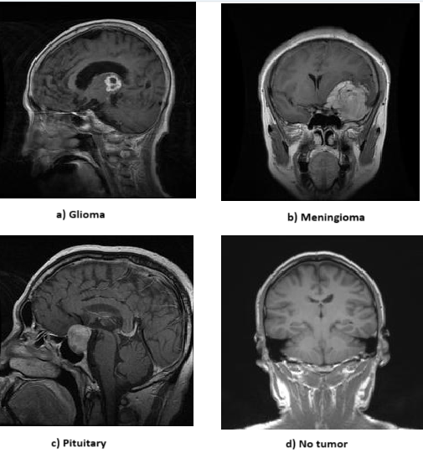

**Figure 3.1.** Sample MRI Images from the Dataset

* 1. **PROPOSED METHODOLOGY**

**EfficientNetB4**

The EfficientNetB4 model architecture was chosen for its efficient scaling and high performance with relatively few parameters.

We used a dataset of MRI brain images categorized into Glioma, Meningioma, Pituitary, No Tumor. We split the dataset into an 82% training set and 18% testing set, where the images were resized to 240x240 pixels for uniformity. Images were normalized to a range of 0 to 1 for convergence improvement. In order to reduce overfitting and enhance generalization of our model, we included data augmentation involving random rotation (up to 20°), random width and height shifts (up to 20°), shear transformation (up to 20%) and zooming (up to 20%) involving vertical and horizontal flipping following similar strategies as used in [48]. The results demonstrated a validation accuracy of 99.76%, consistent with findings from prior studies utilizing EfficientNet variants [49].

The base model utilized EfficientNetB4 pretrained on ImageNet for its scale efficiency and high performance. Custom layers included global average pooling to reduce feature map dimensionality, a dense layer with 1024 units and ReLU activation function for higher-level representation. We also included L2 Regularization to mitigate overfitting and a final dense layer with 4 units and softmax activation for muti-class classification.

For model training, categorical cross entropy was used as the loss function for multi-class classification, and the Adam optimizer with a learning rate of 10-3 was used. Early Stopping mechanism was implemented for halting the training if validation loss did not improve for 5 epochs, model checkpointing was used to save the best model based on validation accuracy, and the learning rate was reduced by a factor of 0.2 if the validation loss did not improve for 3 epochs.

Through these meticulous steps the model was refined to achieve remarkable accuracy, demonstrating its effectiveness in classifying brain tumors. Detailed performance metrics and comparative analysis are discussed in the Results and Discussion Section, where the model’s superior generalization capabilities are highlighted.

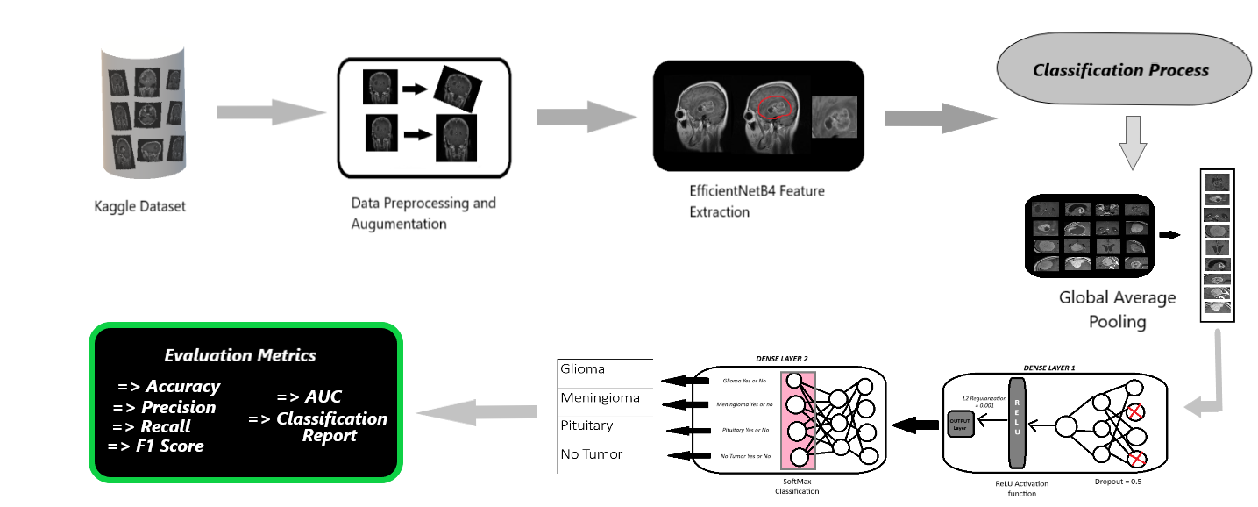

**Figure 3.2.** Schematic Architecture Diagram for EfficientNetB4

**Vision Transformers + EfficientNetB4**

The Vision Transformer (ViT) combined with EfficinetNetB4 architecture leverages the strengths of both models to handle very high-dimensional image data and achieve robust performance. We used the same MRI brain images dataset described earlier, categorized into Glioma, Meningioma, Pituitary and No Tumor. Images were uniformly pre-processed to 224x224 pixels. Images were normalized by rescaling them by (1./255), and data augmentation techniques were applied to the training set to enhance model generalization and reduce overfitting. The techniques include random rotation (up to 20), random width and height shifts (up to 20%), shear transformation (up to 20%), zooming (up to 20%), horizontal and vertical flipping, and brightness adjustments (range 0.8 – 1.2).

The base model utilized the Vit B-32 architecture, pretrained on ImageNet, for its ability to capture long-range dependencies in image data [50]. EfficientNetB4 was integrated for its efficiency and high performance [51]. Custom Layers included global average pooling to reduce the dimensionality of the ViT output. A dense layer with 1024 units and ReLU activation captured higher-level representations. Dropout (0.5 rate) and L2 regularization were used to prevent overfitting. The final dense layer included 4 units (representing brain tumor categories) with softmax activation for multi-class classification.

As per model training, categorical cross entropy was used as the loss function for multi-class classification, and the Adam optimizer with a learning rate of 10-4was used. Early stopping was implemented for halting the training if the validation loss didn’t improve for 5 epochs. Model checkpointing was used to save the best model based on validation accuracy, and the learning rate was made to be reduced by a factor of 0.2 if validation loss didn’t improve for next 3 epochs. The model was trained for 50 epochs with a batch size of 32.

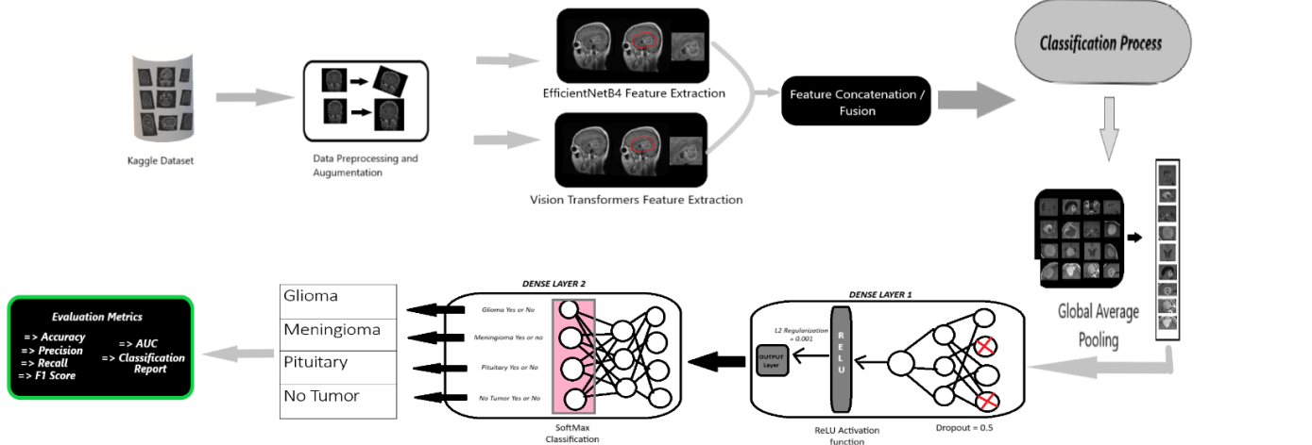

**Figure 3.3.** Schematic Architecture Diagram for Hybrid Model

**Custom 2D CNN**

For the Custom 2D CNN model, we developed a unique architecture specifically tailored for brain tumor classification. The same MRI brain images dataset described earlier, categorized into Glioma, Meningioma, Pituitary, and No Tumor, was used. Images were pre=processed to a uniform size of 224x224 pixels. Normalization (rescaling by 1./255) was applied to all the images, and data augmentation techniques were utilized to enhance model generalization and mitigate overfitting. These augmentation techniques included random rotation (up to 20), width and height shifts (up to 20%), shear transformation (up to 20%), zooming (up to 20%) and horizontal and vertical flipping [52].

The base model was custom-designed 2D Convolutional Neural Network. The architecture included the following custom layers: the first convolution layer with 32 filters and 5x5 kernel size followed by a ReLU activation function, a 2x2 max-pooling layer for down sampling, a second convolutional layer with 64 filters and a 5x5 kernel size followed by ReLU activation function, another 2x2 max-pooling layer, a third convolutional layer with 128 filters and a 5x5 kernel size followed by ReLU activation and a final 2x2 max pooling layer. A flatten layer converted the 3D output to a 1D array, followed by a fully connected layer with 128 units and a sigmoid activation function to capture complex representations. The output layer consisted of 4 units with softmax activation for multi-class classification [53].

The model was trained using categorical cross-entropy as the loss function for multi-class classification and the Adam optimizer with a learning rate of 10-3. Training included early stopping to prevent overfitting if validation loss didn’t improve 5 epochs, model checkpointing to save the best model based on validation accuracy, and learning rate reduction by a factor of 0.2 if validation loss didn’t improve for 3 epochs. The training process lasted for 100 epochs with a batch size of 32.

The detailed performance metrics and comparative analysis of this model, including its final test and validation accuracies, are discussed in the Results and Discussions section [4].

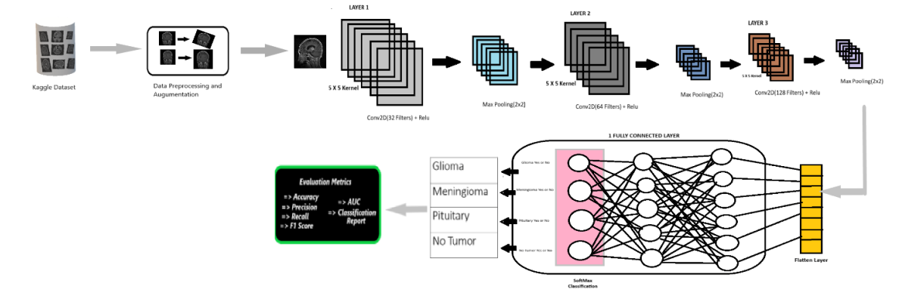

**Figure 3.4.** Schematic Architecture Diagram for 2D CNN

* 1. **CONFUSION MATRIX**

The system model’s effectiveness was evaluated using confusion metrics, which categorize accurate and erroneous prognostications into four distinct classifications

True positive (TP) occurs when both the predicted and actual outcomes are positive.

False positive (FP) occurs when a forecast predicts a positive outcome, but the actual outcome is negative.

True negative (TN) occurs when both the observed outcome and prognostication

are negative.

False negative (FN) occurs when a prediction incorrectly predicts a negative outcome, despite the actual result being positive.

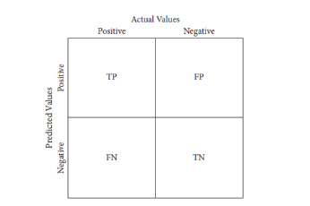

**Figure 3.5.** Confusion Metrics

* 1. **PERFORMANCE METRICS**

Evaluation metrics should constantly be performed, utilizing the system’s all open elements to assess the viability of brain tumor discovery

**Accuracy(ACC) = $\frac{True Positives (TrP)+True Negatives (TrN)}{True Positives (TrP)+False Negatives (FaN)+True Negatives (TrN)+False Positives (FaP)}$**

**Specificity (SPC) = $\frac{True Negatives (TrN)}{True Negatives (TrN)+False Positives (FaP)}$**

**Sensitivity (SEN) or Recall (REC = $\frac{True Positives (TrP)}{True Positives (TrP)+False Negatives (FaN)}$**

**Precision (PREC) = $\frac{True Positives (TrP)}{True Positives (TrP)+False Positives (FaP)}$**

**F1-Score = 2 x $\frac{Precision (PREC)×Sensitivity (SEN)}{Precision (PREC)+Sensitivity (SEN)}$ x 100%**

**Area Under the Curve (AUC) = $\int_{0}^{1}{}Sensitivity \left(SEN\right) d(1-Specificity (SPC))$**

1. **RESULTS AND DISCUSSIONS**

This section demonstrates the experimental results of the above three approaches. Additional tests such as F-score, recall, Precision and Accuracy are utilized to ascertain the experimental outcomes. Let’s look at each methodology and their validation accuracies.

* 1. **EFFICIENTNETB4**

The EfficientNetB4 model demonstrated remarkable performance in classifying MRI brain images into Glioma, Meningioma, Pituitary and No Tumor Categories. The model’s architecture, leveraging efficient scaling and high performance even with fewer parameters, proved to be highly effective. The pre-processing steps, including normalization and data augmentation, played a crucial role in enhancing the model’s generalization capabilities. By applying various augmentation techniques such as random rotation, width and height shifts, zooming and flipping we ensured the model could handle diverse real-world variation in the data.

During the evaluation phase, the EfficientNetB4 model achieved significant accuracy and generalization. The detailed performance metrics highlighting the precision, recall F1-score across all four categories are given below in Table 4.1 and Figure 4.1. As we can clearly see in Figure 4.1 (a) The confusion matrix shows minimal mis-predictions by our model. Figure 4.1 (c) and (d) The ROC Curve and Precision vs Recall curve is predominantly towards the top left corner and top right corner respectively demonstrating strong model performance. Looking at the Training vs Validation Accuracy even though we could observe initial overfitting issues for earlier epochs, the model generalizes pretty well to real world data.

The model consistently maintained high scores in these metrics, indicating its robustness and reliability in classification tasks. For instance, the precision and recall for Glioma, Meningioma, No Tumor and Pituitary categories were near perfect, showcasing the model’s ability to correctly identify and classify each type with minimal errors.

When compared with the Vision Transformer + EfficientNetB4 and Custom 2D CNN models, EfficinetNetB4 stood out for its balanced performance across all classes. While the hybrid model also showed strong performance, EfficientNetB4’s simpler architecture and fewer parameters made it more efficient in terms of computational resources. The custom 2D CNN, although specifically designed for this task, did not achieve the same level of accuracy as EfficientNetB4, highlighting the latter’s superior capabilities in handling complex image classification tasks.

**Training Journey**

During the initial training phase, we set the hyperparameters as follows: rotation range (40), width and height shift range (0.4), shear range (0.3), and zoom range (0.4), including vertical flipping. The learning rate was set to 10-5 and the number of epochs to 10. Our model achieved a validation accuracy of 54.83% with a validation loss of 1.0321 by the 3rd epoch.

To improve this, we increased the training epochs to 30 and removed vertical flipping, as we thought it was irrelevant or detrimental to our data. These changes helped in fine-tuning the model further, minimizing overfitting and enhancing generalization. The model achieved a validation accuracy of 87.75% with a validation loss of 0.3528 during the 8th epoch.

For further improvement, we included horizontal flipping and implemented checkpoints to save the model with the best validation accuracy, reducing the learning rate to 10-4. This led to a model validation accuracy of 94.03% with a validation loss of 0.1809 during the 13th epoch.

We further fine-tuned the model by including a learning rate reduction mechanism, reducing the learning rate by a factor of 0.2 if the validation accuracy didn’t improve for 3 epochs, with a lower limit of 10-6. This prevented the model from oscillating too much and allowed it to converge smoothly by progressively taking smaller steps in the learning process. Ultimately, we achieved a significant milestone: a validation accuracy of 99.76% with a validation loss of 0.2636, and a training accuracy of 99.73% with a training loss of 0.2657.

**Table 4.1:** Classification Report for EffiicientNetB4 Model

|  |  |  |  |  |
| --- | --- | --- | --- | --- |
|  | **Precision** | **Recall** | **F1-Score** | **Support** |
| **Glioma** | 1.00 | 1.00 | 1.00 | 262 |
| **Meningioma** | 0.99 | 1.00 | 1.00 | 306 |
| **No Tumor** | 1.00 | 1.00 | 1.00 | 405 |
| **Pituitary** | 1.00 | 1.00 | 1.00 | 300 |
| **Accuracy** |  |  | 1.00 | 1273 |
| **Macro Average** | 1.00 | 1.00 | 1.00 | 1273 |
| **Weighted Average** | 1.00 | 1.00 | 1.00 | 1273 |

**Table 4.2:** AUC Score per Class

|  |  |
| --- | --- |
| **Class** | **AUC Score** |
| Glioma | 1.000 |
| Meningioma | 0.9996 |
| No Tumor | 1.000 |
| Pituitary | 0.9995 |

1. **(b)**

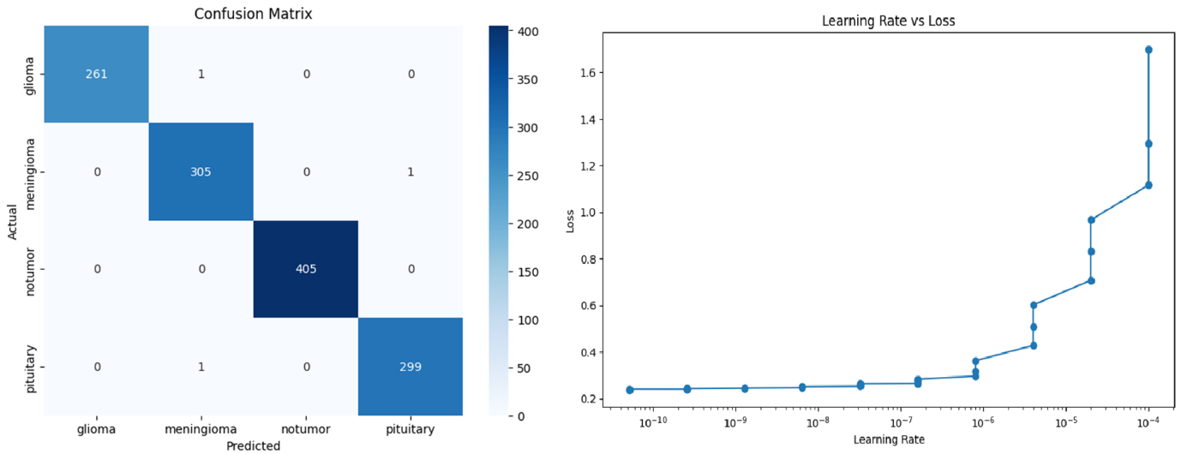

**(c) (d)**

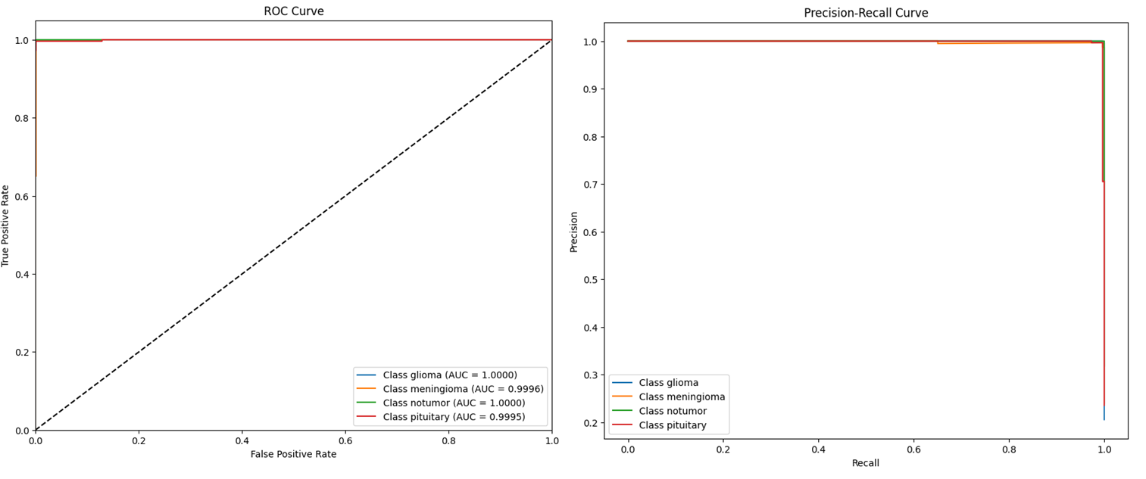

**(e) (f)**

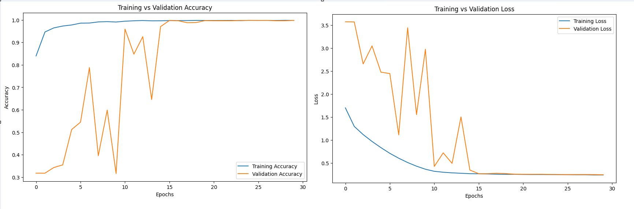

**Figure 4.1.** EfficientNetB4 Performance Analysis (a) Confusion Matrix (b) Learning Rate vs Loss (c) ROC Curve (d) Precision-Recall Curve (e) Training vs Validation Accuracy (f) Training vs Validation Loss

**4.2 HYBRID MODEL (VISION TRANSFORMERS + EFFICIENTNETB4)**

The Vision Transformer + EfficinetNetB4 hybrid model demonstrated a remarkable performance in classifying MRI brain images into Glioma, Meningioma, Pituitary and No Tumor Categories. By combining the strengths of Vision Transformers with the efficient scaling od EfficientNetB4, this hybrid approach proved highly effective.

Pre-processing steps include normalization and various data augmentation techniques, such as random rotation, width and height shifts and flipping. These Steps enhanced the model’s generalization capabilities by ensuring it could handle diverse real-world variation in the data.

The detailed performance metrics highlighting the precision, recall, and F1-score across all four categories are presented in table 4.3 and Figure 4.3. In Figure 4.2 (a)The Confusion matrix for Hybrid Model shows us very minimal misclassification highlighting its capability for generalization. Figure 4.2 (c) and (d) gives us the ROC curve and Precision -Recall Curve is again predominantly towards the top left and top right corner which shows strong model performance. Looking at the Training vs Validation loss graph in Figure 4.3 (f) the close alignment of both the graphs indicates how well the model performs and reduces the overfitting issues.

In comparison with other models, the hybrid model stood out for its enhanced performance across all metrics, particularly due to the combined strengths of the Vision Transformers and EfficinetNetB4. It showed an excellent accuracy with a balanced trade-off between computational resources and performance. Its superior feature extraction and robust pre-processing helped in handling diverse real-world variation efficiently.

**Training Journey**

During the initial phase of training, we set the hyperparameters as follows: rotation range (20), width and height shifts (0.2), shear range (0.2), zoom range (0.2), and included horizontal flipping. We first tested our model for 30 epochs, achieving a validation accuracy of 98.98% with a validation loss of 0.2108 and a learning rate of 10-4 during the 25th epoch.

Further fine-tuning involved including a brightness range [0.8–1.2] in data augmentation. This adjustment improved the validation accuracy to 99.06% during the 27th epoch, with a validation loss of 0.4981 and a learning rate of 2.00 x 10-5.

Curious to explore other architectures, we implemented EfficientNetB9 instead of EfficientNetB4. This yielded a validation accuracy of around 99.29% and a validation loss of 0.5677 with a learning rate of 10-6 during the 21st epoch. However, due to significant overfitting in the initial epochs (Figure 4.2), we reverted to the EfficientNetB4 architecture.

Increasing the training epochs to 50 and employing techniques such as Reduced LR mechanism, Early Stopping, and Checkpoints, our model achieved a validation accuracy of 99.6% with a minimal validation loss of 0.034. The training accuracy was 99.63%, with a training loss of 0.0236. Among all the models, the hybrid model exhibited the lowest validation loss.

**Table 4.3.** Classification Report for Hybrid Model

|  |  |  |  |  |
| --- | --- | --- | --- | --- |
|  | **Precision** | **Recall** | **F1-Score** | **Support** |
| **Glioma** | 1.00 | 1.00 | 1.00 | 262 |
| **Meningioma** | 1.00 | 0.99 | 1.00 | 306 |
| **No Tumor** | 1.00 | 1.00 | 1.00 | 405 |
| **Pituitary** | 0.99 | 0.99 | 0.99 | 300 |
| **Accuracy** |  |  | 1.00 | 1273 |
| **Macro Average** | 1.00 | 1.00 | 1.00 | 1273 |
| **Weighted Average** | 1.00 | 1.00 | 1.00 | 1273 |

**Table 4.4.** AUC Score per Class

|  |  |
| --- | --- |
| **Class** | **AUC Score** |
| Glioma | 1.000 |
| Meningioma | 0.9997 |
| No Tumor | 1.000 |
| Pituitary | 0.9998 |

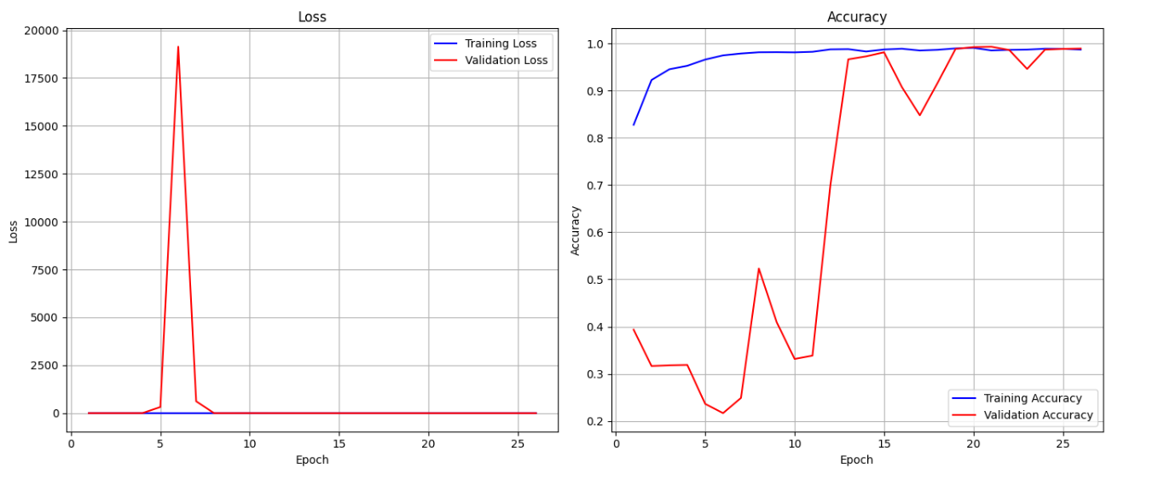

**Figure 4.2.** Training vs Validation Loss and Accuracy of Vision Transformer + EfficientNetB0 architecture

**(a) (b)**

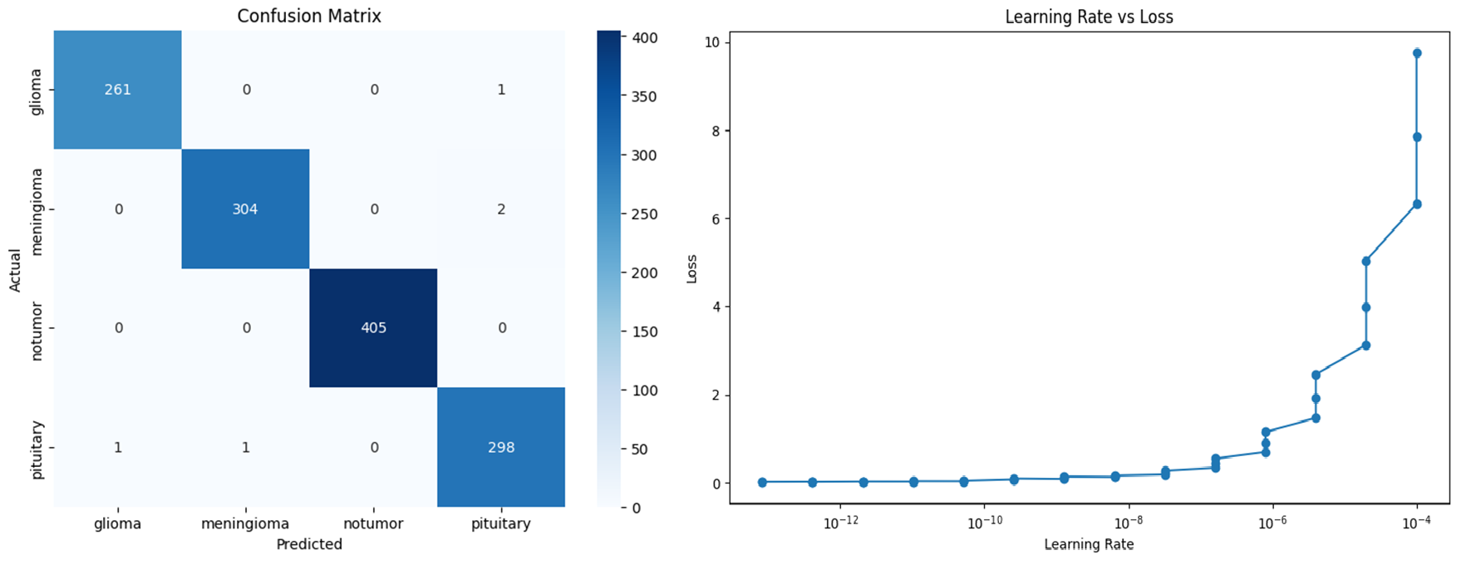

**(c) (d)**

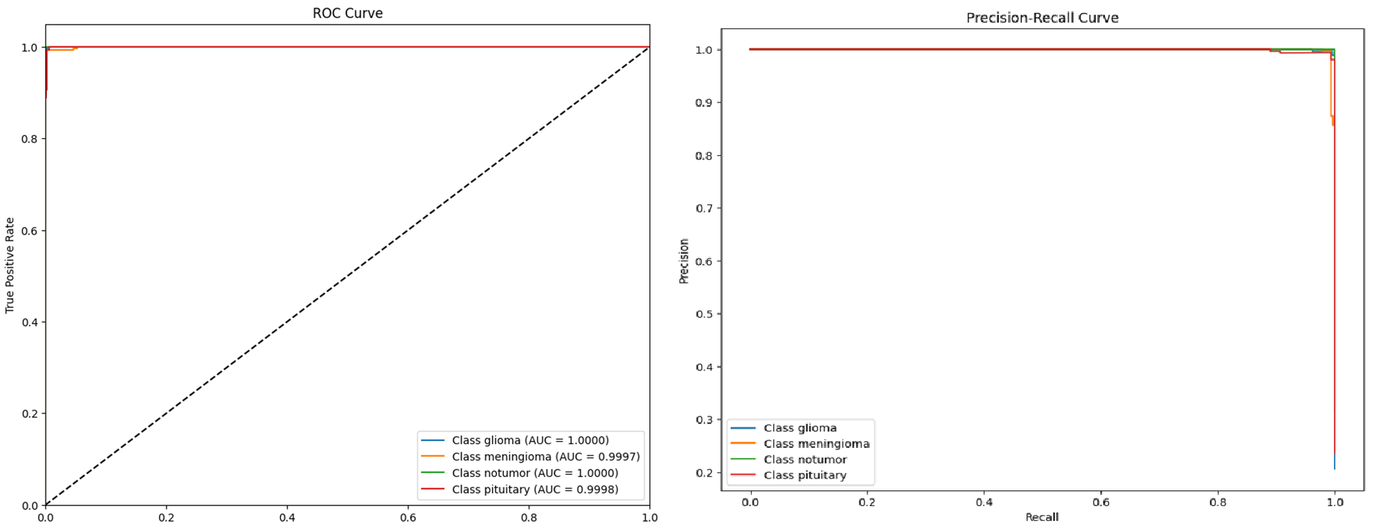

**(e) (f)**

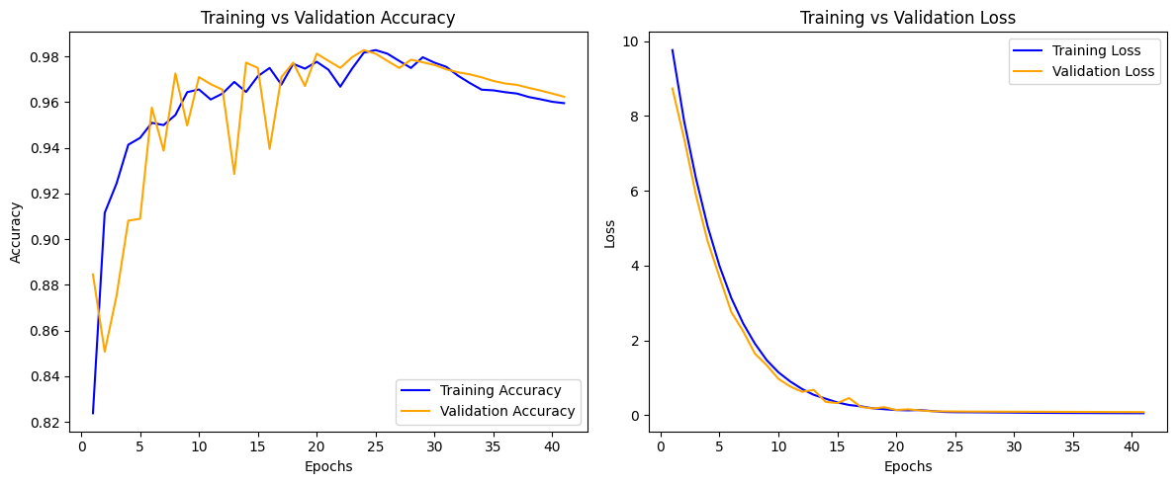

**Figure 4.3.** Hybrid Model Performance Analysis (a) Confusion Matrix (b) Learning Rate vs Loss (c) ROC Curve (d) Precision-Recall Curve (e) Training vs Validation Accuracy (f) Training vs Validation Loss

**4.3 CUSTOM 2D CNN**

The Custom 2D CNN model demonstrated significant potential in classifying MRI brain images into Glioma, Meningioma, Pituitary, and No Tumor categories. The architecture, tailored specifically for this task, focused on extracting features pertinent to brain tumor classification.

The pre-processing steps included normalization and data augmentation techniques like random rotation, width and height shifts, zooming, and horizontal flipping. These steps helped in enhancing the model’s ability to generalize by training on diverse variations of the data.

Despite being a custom architecture, the 2D CNN model achieved competitive performance. The detailed performance metrics, including precision, recall, and F1-score for each category, are presented in Table 4.5 and Figure 4.4.

While the Custom 2D CNN showed strong classification capabilities, it did not outperform the Vision Transformer + EfficientNetB4 hybrid model or EfficientNetB4 model. The validation accuracy and loss metrics, as detailed in Table 4.2, indicated that the Custom 2D CNN model had room for improvement in terms of handling overfitting and achieving higher generalization.

The model achieved a validation accuracy of 92.77% with a validation loss of 0.1941. Training accuracy was 92.61% with a training loss of 0.1976. The precision and recall for the Glioma, Meningioma, No Tumor, and Pituitary categories were respectable, but slightly lower compared to the other models.

Overall, while the Custom 2D CNN model provided a robust baseline and demonstrated the effectiveness of a tailored architecture, the comparative performance highlighted the superior capabilities of the hybrid and EfficientNetB4 models in handling complex image classification tasks.

**Training Journey**

During the initial training phase, we employed the ReLU activation function and set the kernel size to 3x3. The number of kernels in each layer was configured as follows: 32 kernels in the first layer, 64 in the second layer, and 128 in the third layer. Additionally, our model included one fully connected layer, one dense layer, and three max-pooling layers of 2x2. This setup achieved a validation accuracy of 91.59% with a validation loss of 0.2400.

Subsequently, we experimented with different kernel sizes (5x5 and 7x7), but observed no significant improvement in validation accuracy. Next, we switched the activation function to Sigmoid while keeping other hyperparameters unchanged. This adjustment increased the validation accuracy to 92.77%, with a validation loss of 0.1941.

Further attempts to fine-tune the model involved incorporating elastic L1 and L2 regularization. However, this led to a decrease in validation accuracy to 87.04% and an increase in validation loss to 0.6455. Finally, we explored the use of the tanH activation function without any regularization. Training the model for 50 epochs with this configuration resulted in a validation accuracy of 92.22% and a validation loss of 0.1881.

Finally, we trained our model for 100 epochs with early stopping, reduced learning rate, and checkpoint mechanisms intact. Our model achieved an impressive validation accuracy of 97.25% with a validation loss of 0.083. The training accuracy was 95.83% with a training loss of 0.1155.

**Table 4.5.** Classification Report for Custom 2D CNN

|  |  |  |  |  |
| --- | --- | --- | --- | --- |
|  | **Precision** | **Recall** | **F1-Score** | **Support** |
| **Glioma** | 1.00 | 0.92 | 0.96 | 262 |
| **Meningioma** | 0.93 | 0.95 | 0.94 | 306 |
| **No Tumor** | 0.97 | 1.00 | 0.99 | 405 |
| **Pituitary** | 0.98 | 0.99 | 0.99 | 300 |
| **Accuracy** |  |  | 0.97 | 1273 |
| **Macro Average** | 0.97 | 0.97 | 0.97 | 1273 |
| **Weighted Average** | 0.97 | 0.97 | 0.97 | 1273 |

**Table 4.6.** AUC Score per Class

|  |  |
| --- | --- |
| **Class** | **AUC Score** |
| Glioma | 0.9983 |
| Meningioma | 0.9937 |
| No Tumor | 0.9997 |
| Pituitary | 0.9998 |

**(a) (b)**

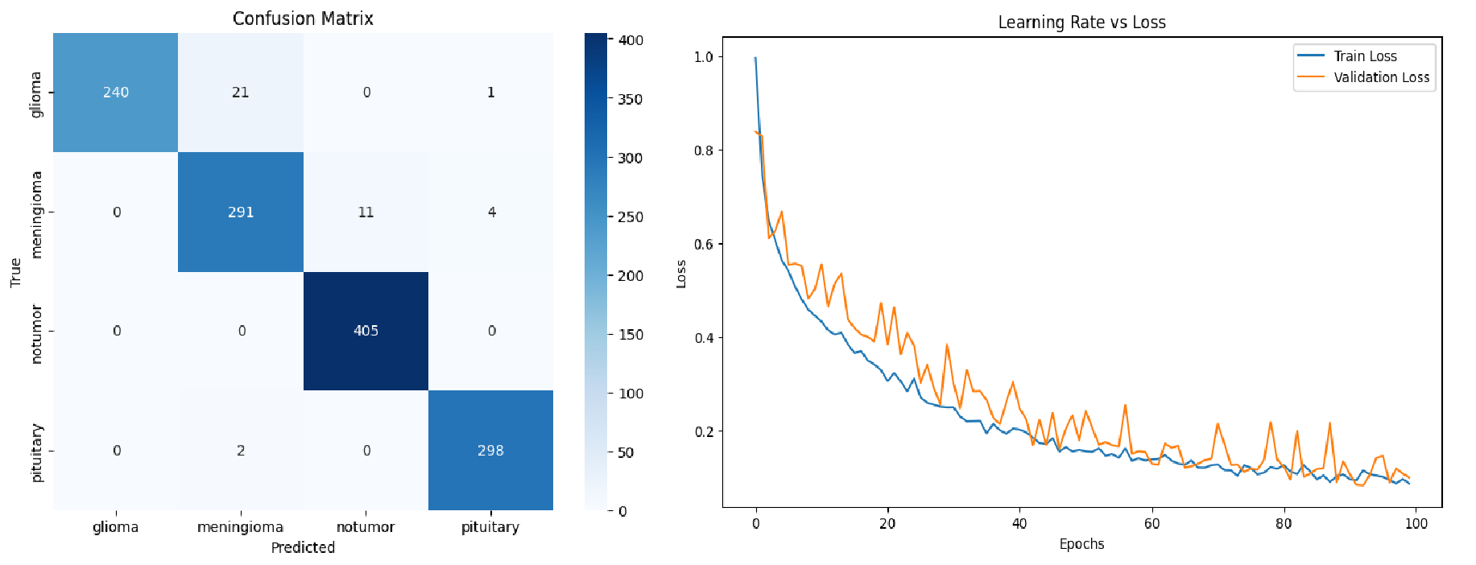

**(c) (d)**

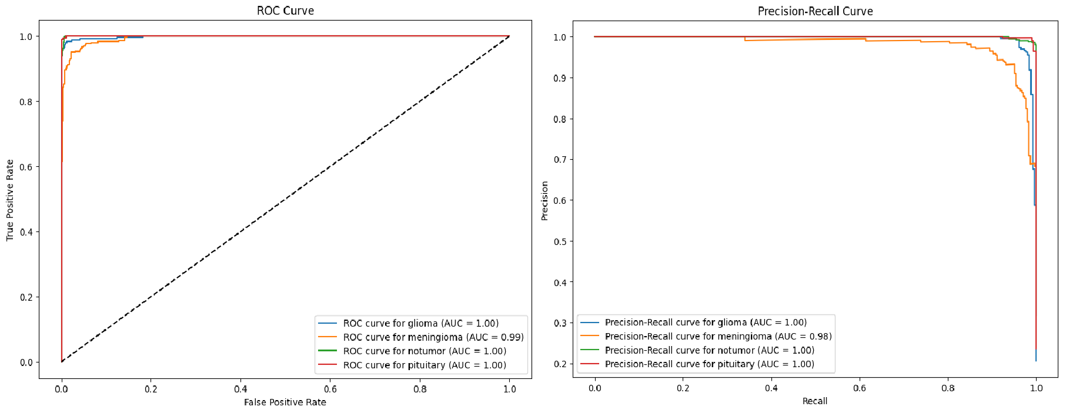

**(e) (f)**

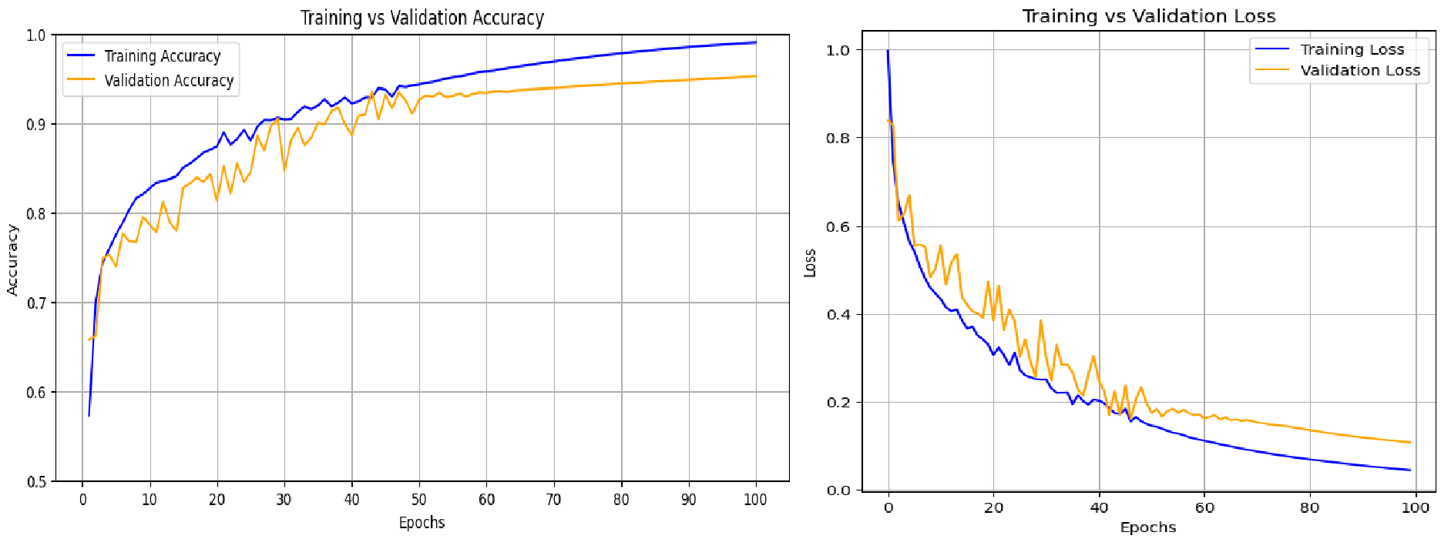

**Figure 4.4.** Custom 2D CNN Performance Analysis (a) Confusion Matrix (b) Learning Rate vs Loss (c) ROC Curve (d) Precision-Recall Curve (e) Training vs Validation Accuracy (f) Training vs Validation Loss

**4.4 PERFORMANCE COMPARISON**

In **Figures 4.5. (a)**, **(b)**, and **(c)** illustrate the accuracy for each class (Glioma, Meningioma, Pituitary, and No Tumor) across the three models. These graphs highlight the models' proficiency in correctly classifying each tumor type, demonstrating EfficientNetB4's superior accuracy in comparison to the other models.

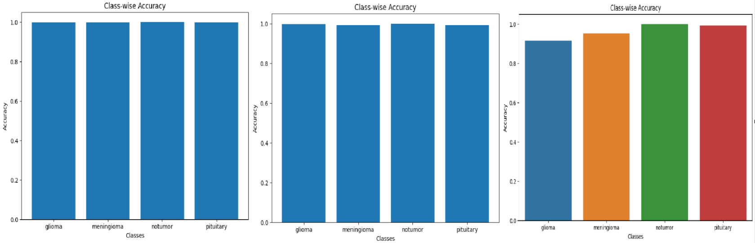

1. **(b) (c)**

**Figure 4.5.** Class-wise Accuracy Comparison (a) EfficientNetB4 (b) Hybrid Model (c) Custom 2D CNN

In **Figure 4.6.** shows the AUC scores for each class of brain tumor. This metric provides insight into the models' overall ability to distinguish between different classes, where both EfficientNetB4 and the Hybrid Model achieved near-perfect AUC scores, indicating excellent classification performance.

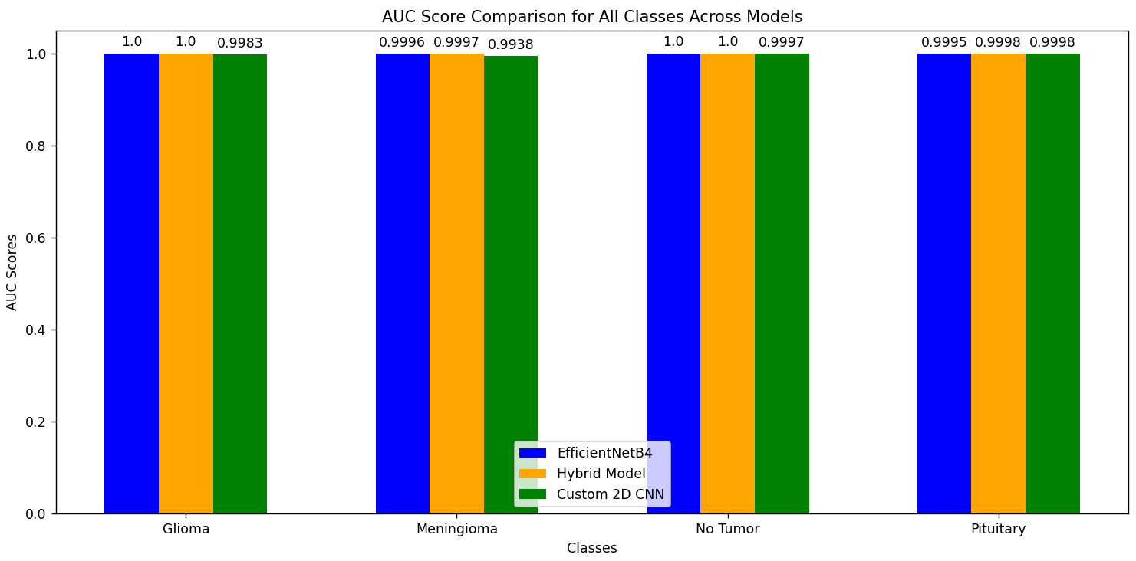

**Figure 4.6.** Model Based Comparison on AUC Scores for each class of brain tumor

In **Figure 4.7.** compares the training accuracy across models. EfficientNetB4 quickly achieves near-perfect accuracy, followed by the Hybrid Model with slightly lower but still high accuracy. The Custom 2D CNN shows a gradual improvement, achieving competitiveaccuracy over time.

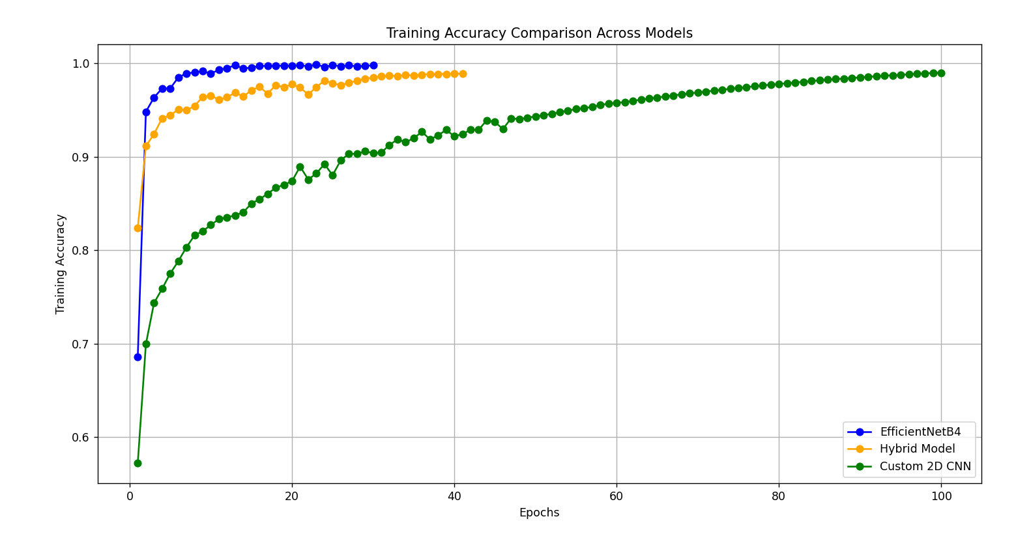

**Figure 4.7.** Model Based Comparison on Training Accuracy across epochs

In **Figure 4.8.** compares the validation accuracy across models. The Hybrid Model shows the highest and most stable validation accuracy, followed by EfficientNetB4, which stabilizes around 0.95, and the Custom 2D CNN, which shows steady improvement, stabilizing around 0.9 after 40 epochs.

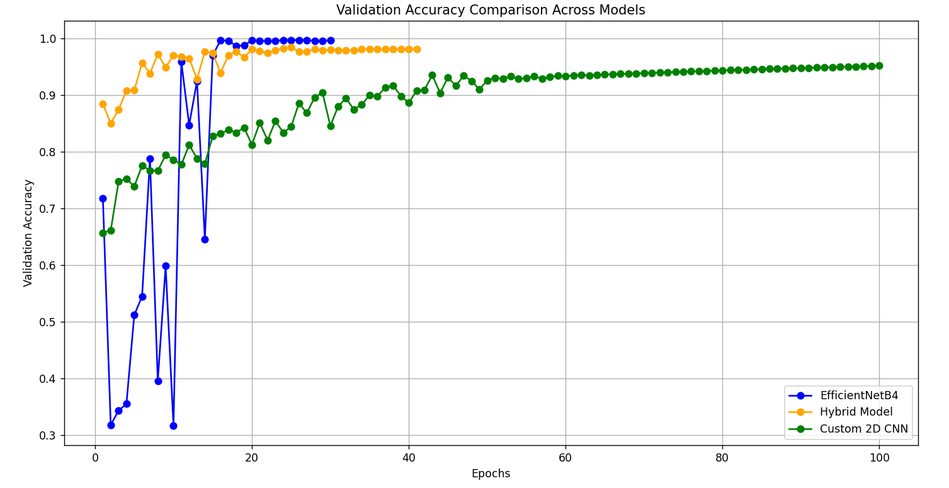

**Figure 4.8.** Model Based Comparison on Validation Accuracy across epochs

In **Figure 4.9**. compares the training loss of each model across the training epochs. EfficientNetB4 and the Hybrid Model demonstrate a faster convergence rate with a steady decrease in training loss, while the Custom 2D CNN exhibits more fluctuations.

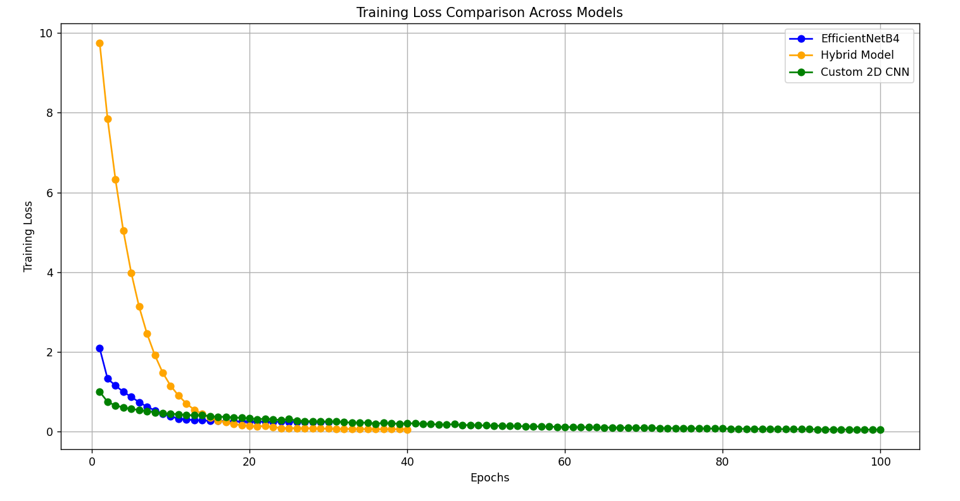

**Figure 4.9.** Model Based Comparison on Training Loss

In **Figure 4.10.** compares the validation loss for the three models. Lower validation loss indicates better generalization to new, unseen data. EfficientNetB4 and the Hybrid Model consistently maintain low validation loss, underscoring their robustness in real-world scenarios.

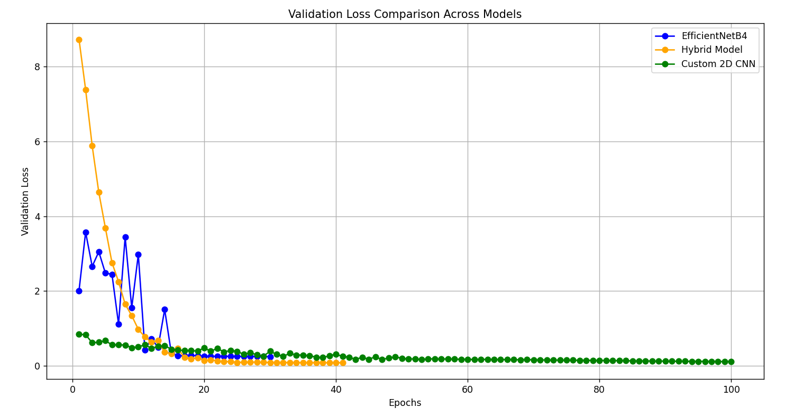

**Figure 4.10.** Model Based Comparison on Validation Loss

In **Figure 4.11.** presents a heatmap of the confusion matrices, providing a visual comparison of misclassifications. EfficientNetB4 shows the least misclassifications, emphasizing its reliability in accurate predictions, followed closely by the Hybrid Model.

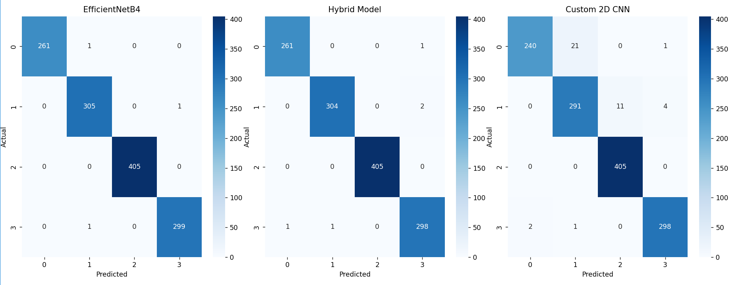

**Figure 4.11.** Heatmap formodel-based comparison on Confusion matrix

In **Figure 4.12.** shows the ROC curves for the three models, illustrating their performance. EfficientNetB4 and the Hybrid Model exhibit near-perfect classification with ROC curves close to the top left, while Custom 2D CNN shows strong yet slightly lower performance.

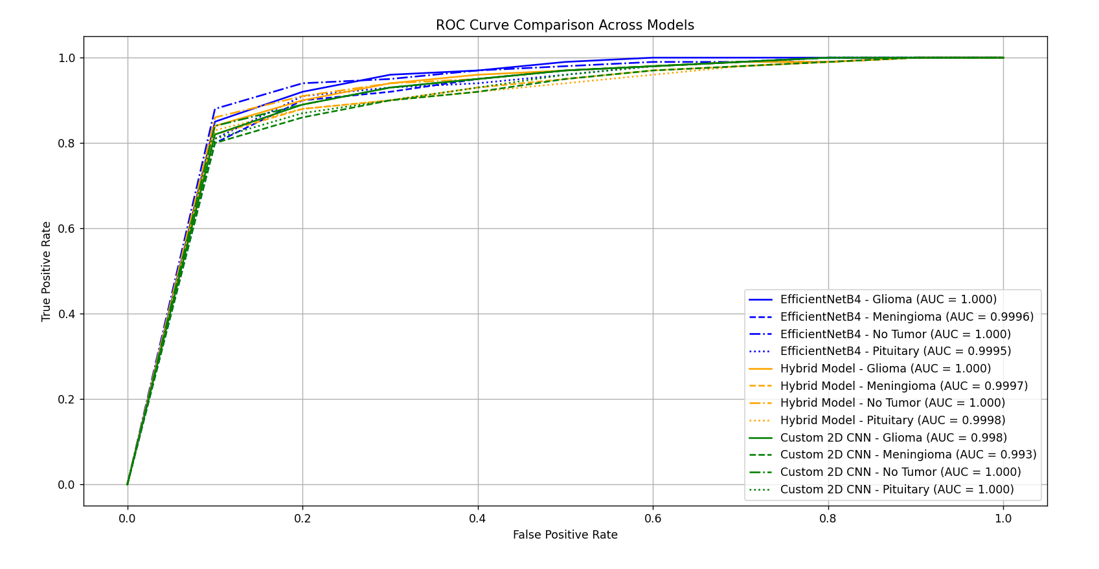

**Figure 4.12.** ROC Comparison on models

In **Figure 4.13.** shows the ROC curves for the three models, illustrating their performance. EfficientNetB4 and the Hybrid Model exhibit near-perfect classification with ROC curves close to the top left, while Custom 2D CNN shows strong yet slightly lower performance.

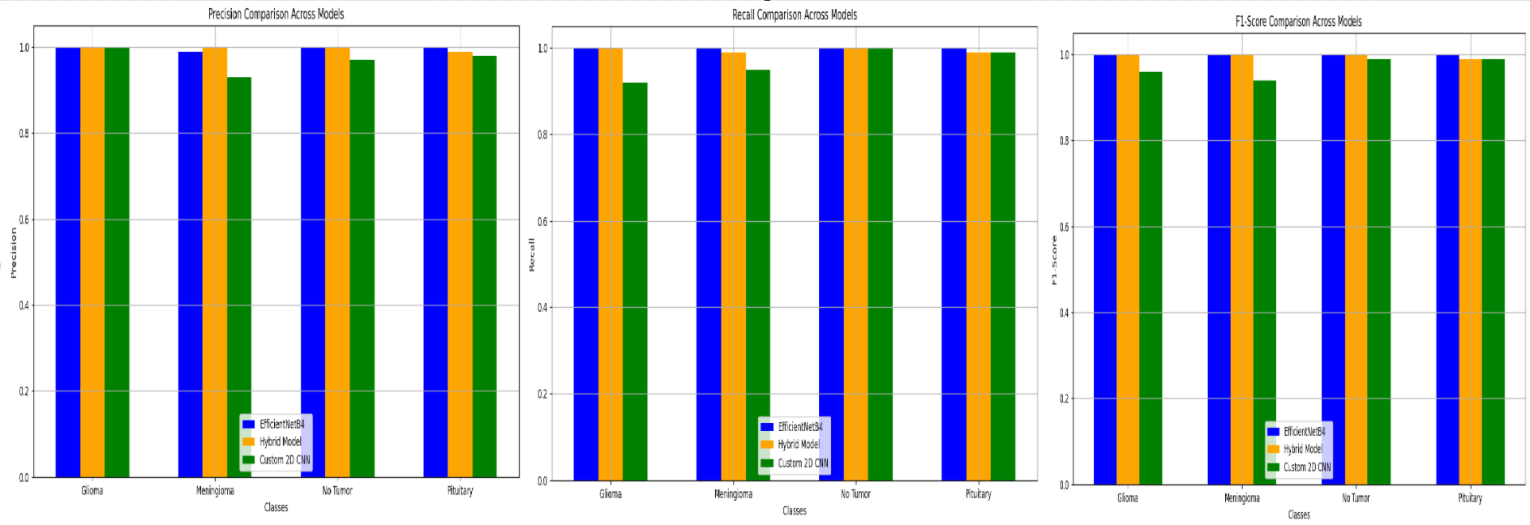

1. **(b) (c)**

**Figure 4.13.** Performance Metrics Comparison: (a) Precision (b) Recall (c) F1-Score

In **Figure 4.14.** provides a comparison of precision, recall, and F1-scores across different classes for the three models. EfficientNetB4 consistently achieves the highest scores, followed by the Hybrid Model, while the Custom 2D CNN shows competitive yet slightly lower performance.

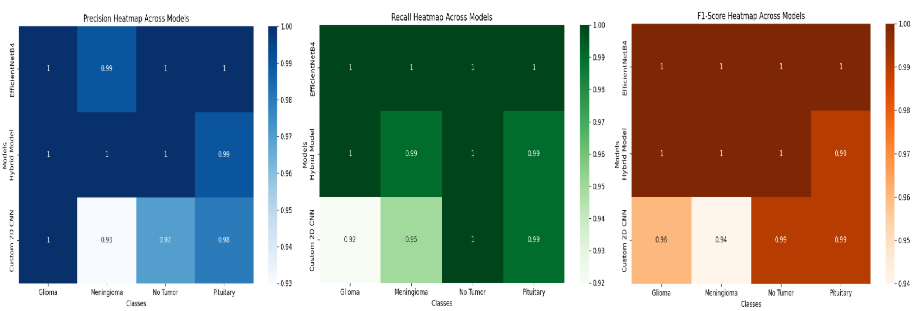

1. **(b) (c)**

**Figure 4.14.** Heatmaps for Precision, Recall, and F1-Score across all three models: (a) EfficientNetB4 (b) Hybrid Model (c) Custom 2D CNN

In **Figure 4.15.** compares the training times across epochs for all models. EfficientNetB4 demonstrates the shortest training times, while the Custom 2D CNN has the longest due to a higher number of epochs. The Hybrid Model falls in between.

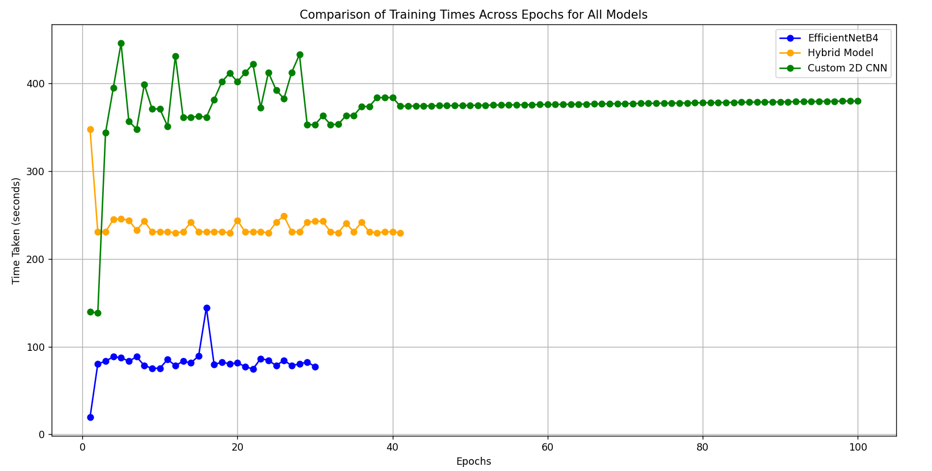

**Figure 4.15.** Comparison of Training Times Across Epochs for All Models

1. **PROPOSED FUTURE WORK**

In the proposed future work, we aim to enhance our model's performance and address potential challenges in brain tumor detection and classification. Our current models, such as EfficientNetB4, a hybrid Vision Transformer + EfficientNetB4, and a custom CNN model, yield promising results. However, several improvements can increase their reliability.

Future research will integrate multiple imaging modalities, like CT or PET scans, alongside MRI, to enhance tumor characterization. While our models have performed well on the Kaggle dataset, they have yet to be tested in real-world scenarios. Addressing challenges such as class imbalance, where some tumors appear less frequently in the data, will be crucial. We plan to incorporate techniques like Generative Adversarial Networks (GANs) and advanced data augmentation to create additional examples of rarer tumor types, enhancing the model's ability to recognize them.

Since transparency is essential in medical diagnostics, we plan to use explainable AI tools like Grad-CAM and SHAP. These tools will help build trust in the model’s decisions. To make a real difference, our models could be integrated into clinical processes as tools to support doctors in decision-making. Future steps will focus on creating easy-to-use interfaces, enabling real-time processing, and testing the models' usefulness in healthcare settings through pilot studies.

Additionally, we see potential in using MRI sequences to study how tumors change over time, which could allow for predictive insights into tumor growth. This could be achieved by applying techniques such as Recurrent Neural Networks (RNNs) or Temporal Convolutional Networks (TCNs). These improvements aim to develop a more adaptable, understandable, and effective model, providing healthcare professionals with practical insights that support early diagnosis and more informed treatment planning.

We also plan to integrate multi-modal data, such as genetic and molecular markers, with MRI scans to gain a deeper understanding of each tumor’s characteristics, enhancing both classification accuracy and progression predictions. This holistic approach would support personalized treatment planning by providing clinicians with richer context around each case.

Another promising direction is developing adaptive models that update themselves with new data, ensuring the system stays current with evolving diagnostic standards and advances in imaging. Such adaptability would improve the model’s robustness across different imaging technologies and clinical practices, making it versatile for use in diverse healthcare settings. We also plan to reduce the model’s memory and processing demands so it can operate effectively on standard hospital equipment, eliminating the need for specialized hardware.

1. **CONCLUSION**

We considered several deep learning models in this study in the context of classifying MRI brain images into four categories: Glioma, Meningioma, Pituitary, and No Tumor. Our experiments involved the hybrid Vision Transformer + EfficientNetB4 model, Custom 2D CNN, and EfficientNetB4. Each of the deep learning models showed great potential, and the best model was the EfficientNetB4 with the highest accuracy and a balanced performance by the hybrid model on all metrics.

Very efficient and very high accuracy EfficientNetB4 with far fewer parameters scaling well Hybrid model took the best from both worlds- Vision Transformers and EfficientNetB4; in turn, achieving good generalization with great performance The base line offered by the custom 2D CNN showed promising robustness yet has a lot of leeway for further improvement.  
  
We had faced the following challenges and problems in our research: overfitting and class imbalance. We reduced some cases of overfitting and improved the generalization of our models, aided by using more developed data augmentation and fine-tuning of hyperparameters. More successful techniques were reducing the learning rate and early stopping.

Future work will involve further integration of other imaging modalities like CT or PET scans with MRI for improved characterization of tumors. GANs and other forms of advanced data augmentation to handle class imbalance will continue to be worked on. Explainable AI tools are also something we would want to work on for us to gain confidence in our models and further integrate them into clinical workflows, thus ensuring real-time processing and enabling doctors to make the proper decisions.

We have shown the possibility that deep learning models can be successful in brain tumor classification tasks, providing useful insights as well as a foundation for future research. Using new techniques and overcoming the associated challenges, our models would have a huge impact in clinical settings in terms of early diagnosis and treatment planning, thus improving patient outcome.

For more details on our model and code please refer to [Brain Tumor Classification using Multiple Deep Learning Models](https://github.com/SelvaKarthik01/Brain-Tumor-Classification)

1. **REFERENCES**

[1] Akmalbek Bobomirzaevich Abdusalomov, Mukhriddin Mukhiddinov 1, Taeg Keun Whangbo 1, “Brain Tumor Detection Based on Deep Learning Approaches and Magnetic Resonance Imaging”., doi: [10.3390/cancers15164172](https://doi.org/10.3390/cancers15164172)

[2] Sandeep Kumar Mathivanan, Sridevi Sonaimuthu, Sankar Murugesan, Hariharan Rajadurai, Basu Dev Shivahare & Mohd Asif Shah, “Employing deep learning and transfer learning for accurate brain tumor detection”, doi: <https://doi.org/10.1038/s41598-024-57970-7>

[3] Novsheena Rasool 1, Javaid IqbalBhat, “Brain tumour detection using machine and deep learning: a systematic review”, DOI:[10.1007/s11042-024-19333-2](http://dx.doi.org/10.1007/s11042-024-19333-2)

[4] P.S. Smitha.,G. Balaarunesh,C. Sruthi Nath,Aminta Sabatini S, “Classification of brain tumor using deep learning at early stage” , doi: <https://doi.org/10.1016/j.measen.2024.101295>

[5] Shikha Jain; Bhawna Sachdeva, “A systematic review on brain tumor detection using deep learning”, doi: <https://doi.org/10.1063/5.0221113>

[6] B. Sandhiya a,S. Kanaga Suba Raja b, “Deep Learning and Optimized Learning Machine for Brain Tumor Classification”, doi: <https://doi.org/10.1016/j.bspc.2023.105778>

[7] Soheila Saeedi, Sorayya Rezayi, Hamidreza Keshavarz & Sharareh R. Niakan Kalhori, “MRI-based brain tumor detection using convolutional deep learning methods and chosen machine learning techniques”, [doi: https://doi.org/10.1186/s12911-023-02114-6](doi:%20https://doi.org/10.1186/s12911-023-02114-6)

[8] Muhammad Aamir,Abdallah Namoun 3,Sehrish Munir 1,Nasser Aljohani 3,Meshari Huwaytim Alanazi 4,,Yaser Alsahafi 5 andFaris Alotibi 6 “Brain Tumor Detection and Classification Using an Optimized Convolutional Neural Network” doi: [**https://doi.org/10.3390/diagnostics14161714**](https://doi.org/10.3390/diagnostics14161714)

[9] Md Kamrul Hasan Khan 1, Wenjing Guo 1, Jie Liu 1, Fan Dong 1, Zoe Li 1, Tucker A Patterson 1, Huixiao Hong 1, “Machine learning and deep learning for brain tumor MRI image segmentation”, doi: <https://doi.org/10.1177/15353702231214259>

[10] K. Nishanth Raoa ∙ Osamah Ibrahim Khalafb ∙ V. Krishnasreec ∙ Aruru Sai Kumarc ∙ Deema Mohammed Alsekaitd ∙ S. Siva Priyankae ∙ Ahmed Saleh Alattasf ∙ Diaa Salama AbdElminaamg, “An efficient brain tumor detection and classification using pre-trained convolutional neural network models” <https://doi.org/10.1016/j.heliyon.2024.e36773>

[11] Muhammad S. Ghauri 1,2, Jen-Yeu Wang 1,Akshay J. Reddy 1,Talha Shabbir 1,Ethan Tabaie 3 andJaved Siddiqi 1,2, “Brain Tumor Recognition Using Artificial Intelligence Neural-Networks (BRAIN): A Cost-Effective Clean-Energy Platform”, [doi: https://doi.org/10.3390/neuroglia5020008](doi:%20https://doi.org/10.3390/neuroglia5020008)

[12] Balamurugan A.G, Saravanan Srinivasan, Preethi D, Monica P, Sandeep Kumar Mathivanan & Mohd Asif Shah, “ Robust brain tumor classification by fusion of deep learning and channel-wise attention mode approach”, doi : <https://doi.org/10.1186/s12880-024-01323-3>

[13] Chetan Swarup 1 , Kamred Udham Singh 2 , Ankit Kumar 3 Saroj Kumar Pandey 3 , Neeraj varshney 3 , Teekam Singh 4 “Brain tumor detection using CNN, AlexNet & GoogLeNet ensembling learning approaches”, doi : <https://doi.org/10.3934/era.2023146>

[14] Seyed Masoud Ghoreishi Mokri, Newsha Valadbeygi,Vera Grigoryeva, “Diagnosis of Glioma, Menigioma and Pituitary brain tumor using MRI images recognition by Deep learning in Python” , doi: <https://doi.org/10.4108/eetismla.5410>

[15] SHUBHANGI SOLANKI 1, UDAY PRATAP SINGH 2, (Member, IEEE), SIDDHARTH SINGH CHOUHAN 3 , AND SANJEEV JAIN4 , (Member, IEEE) “Brain Tumor Detection and Classification Using Intelligence Techniques: An Overview” , doi: <https://doi.org/10.1109/ACCESS.2023.3242666>

[16] Sahoo, Debendra Kumar; Mishra, Satyasish; Mohanty, Mihir Narayan1; Behera, Rajesh Kumar2,; Dhar, Srikant Kumar3 “Brain Tumor Detection using Deep Learning Approach” , doi : <https://doi.org/10.4103/0028-3886.383858>

[17] Patel Rahulkumar Manilal, D. J. Shah “Early Detection of Brain Tumors: A Comprehensive Study on MRI-Based Diagnosis Using a Combination of Convolutional Deep Learning and Machine Learning Techniques” <https://ijisae.org/index.php/IJISAE/article/view/6380>

[18] K. Rasool ReddyK. Rasool Reddy1Kandala N. V. P. S. Rajesh

Kandala N. V. P. S. Rajesh2*Ravindra DhuliRavindra Dhuli2Vuddagiri Ravi KumarVuddagiri Ravi Kumar3 “BrainCDNet: a concatenated deep neural network for the detection of brain tumors from MRI images”, doi: <https://doi.org/10.3389/fnhum.2024.1405586>

[19] Naeem Ullah,Ali Javed,Ali Alhazmi,Syed M. Hasnain ,Ali Tahir,Rehan Ashraf “TumorDetNet: A unified deep learning model for brain tumor detection and classification”,doi: <https://doi.org/10.1371/journal.pone.0291200>

[20] Anisa C. Buchade | MVV Prasad Kantipudi, “Recent Trends on Brain Tumor Detection Using Hybrid Deep Learning Methods”, doi: <https://doi.org/10.18280/ria.380111>

[21] Seyed Matin Malakouti, Mohammad Bagher Menhaj ,Amir Abolfazl Suratgar “Machine learning and transfer learning techniques for accurate brain tumor classification”, doi: <https://doi.org/10.1016/j.ceh.2024.08.001>

[22] Vikram Verma; Alankrita Aggarwal; Tajinder Kumar “Machine and Deep Learning Approaches For Brain Tumor Identification: Technologies, Applications, and Future Directions”, doi: <https://doi.org/10.1109/CISES58720.2023.10183492>

[23] A. Keerthana1, B. Kavin Kumar1, K.S Akshaya1 and S. Kamalraj Ph.D “Brain Tumour Detection Using Machine Learning Algorithm”, doi : <https://doi.org/10.1088/1742-6596/1937/1/012008>

[24] Javaria Amin, Muhammad Sharif, Anandakumar Haldorai, Mussarat Yasmin & Ramesh Sundar Nayak, “Brain tumor detection and classification using machine learning: a comprehensive survey”, doi: <https://doi.org/10.1007/s40747-021-00563-y>

[25] Manav Sharma, Pramanshu Sharma, Ritik Mittal, Kamakshi Gupta, “Brain Tumour Detection Using Machine Learning” , doi: <https://doi.org/10.36548/jei.2021.4.005>

[26] Rajan Hossain, Roliana Binti Ibrahim, Haslina Binti Hashim, “Automated Brain Tumor Detection Using Machine Learning: A Bibliometric Review”,dio: <https://doi.org/10.1016/j.wneu.2023.03.115>

[27] M. Aarthilakshmi, S. Meenakshi, A. Poorna Pushkala, V. Rama@Ramalakshmi, N.B. Prakash. ‘Brain Tumor Detection Using Machine Learning” <https://www.ijstr.org/final-print/apr2020/Brain-Tumor-Detection-Using-Machine-Learning.pdf>

[28] Asma Parveen A, Dr.T.Kamalakannan, “A Research on Brain Tumor detection using Machine Learning techniques and Deep Learning approach” <https://www.jetir.org/view?paper=JETIR2309630>

[29] Siddhant barshile , Subham patil , Hemant Bhujbal, Prof. K.C.Nalavade Mam, “BRAIN CANCER DETECTION USING MACHINE LEARNING.” <https://ijcrt.org/papers/IJCRT2203295.pdf>

[30] ALAKUNTLA RAJA SHEKAR, Department of Information technology, JNTUH UCESTH, DR.G.VENKATA RAMI REDDY, Professor of IT, JNTUH UCESTH “Brain Tumour Detection Using Machine Learning” <https://www.ijarst.in/public/uploads/paper/920741694703997.pdf>

[31] Md. Mahfuz Ahmed, Md. Maruf Hossain, Md. Rakibul Islam, Md. Shahin Ali, Abdullah Al Noman Nafi, Md. Faisal Ahmed, Kazi Mowdud Ahmed, Md. Sipon Miah, Md. Mahbubur Rahman, Mingbo Niu & Md. Khairul Islam, “Brain tumor detection and classification in MRI using hybrid ViT and GRU model with explainable AI in Southern Bangladesh”, doi : <https://doi.org/10.1038/s41598-024-71893-3>

[32] Baiju Babu Vimala, Saravanan Srinivasan, Sandeep Kumar Mathivanan, Mahalakshmi, Prabhu Jayagopal & Gemmachis Teshite Dalu “Detection and classification of brain tumor using hybrid deep learning models”, doi : <https://doi.org/10.1038/s41598-023-50505-6>

[33] A. Priya,V. Vasudevan , “Brain tumor classification and detection via hybrid alexnet-gru based on deep learning” , dio : <https://doi.org/10.1016/j.bspc.2023.105716>

[34] Jose Dixon 1,Oluwatunmise Akinniyi 1,Abeer Abdelhamid 2,Gehad A. Saleh 3,Md Mahmudur Rahman 4 and Fahmi Khalifa “A Hybrid Learning-Architecture for Improved Brain Tumor Recognition” , doi : <https://doi.org/10.3390/a17060221>

[35] A. Rohini, Carol Praveen, Sandeep Kumar Mathivanan, V. Muthukumaran, Saurav Mallik, Mohammed S. Alqahtani, Amal Al-Rasheed & Ben Othman Soufiene “Multimodal hybrid convolutional neural network based brain tumor grade classification”, doi : <https://doi.org/10.1186/s12859-023-05518-3>

[36] Saeed Mohsen; Anas M. Ali; El-Sayed M. El-Rabaie; Ahmed ElKaseer; Steffen G. Scholz; Ashraf Mohamed Ali Hassan “Brain Tumor Classification Using Hybrid Single Image Super-Resolution Technique With ResNext101_32× 8d and VGG19 Pre-Trained Models” , doi : <https://doi.org/10.1109/ACCESS.2023.3281529.>

[37] T. Balamurugan, E. Gnanamanoharan, “Brain Tumor Segmentation and Classification using hybrid Deep CNN with LuNet Classifier”, doi: <https://doi.org/10.21203/rs.3.rs-1599383/v1>

[38] Ebrahim Mohammed Senan, Mukti E. Jadhav, Taha H. Rassem, Abdulaziz Salamah Aljaloud, Badiea Abdulkarem Mohammed, Zeyad Ghaleb Al-Mekhlafi, “Early Diagnosis of Brain Tumour MRI Images Using Hybrid Techniques between Deep and Machine Learning”, doi: [**https://doi.org/10.1155/2022/8330833**](https://doi.org/10.1155/2022/8330833)

[39] Gehad Abdullah Amran 1,Mohammed Shakeeb Alsharam 3,Abdullah Omar A. Blajam 4,Ali A. Hasan 5,Mohammad Y. Alfaifi 6,Mohammed H. Amran 7,Abdu Gumaei 8 andSayed M. Eldin 9, “Brain Tumor Classification and Detection Using Hybrid Deep Tumor Network” , doi: <https://doi.org/10.3390/electronics11213457>

[40] Fatma E AlTahhan 1, Ghada A Khouqeer 2, Sarmad Saadi 3, Ahmed Elgarayhi 3, Mohammed Sallah 3,4, “Refined Automatic Brain Tumor Classification Using Hybrid Convolutional Neural Networks for MRI Scans”, doi: <https://doi.org/10.3390/diagnostics13050864>

[41] Kaggle Dataset: <https://dx.doi.org/10.21227/2qfw-bf10>.

[42] Kaggle Dataset: <https://www.kaggle.com/abhranta/brain-tumor-detection-mri>

[43] Kaggle Dataset: <https://www.kaggle.com/datasets/jakeshbohaju/brain-tumor>

[44] <https://my.clevelandclinic.org/health/diseases/6149-brain-cancer-brain-tumor>

[45] <https://www.mayoclinic.org/diseases-conditions/brain-tumor/symptoms-causes/syc-20350084>

[46] <https://www.aaroncohen-gadol.com/en/patients/brain-tumor/types/statistics>

[47] Antony Dennis Ananth, Chenniappan Palanisamy,” Extended and optimized deep convolutional neural network-based lung tumor identification in big data‟, International Journal of Imaging Systems and Technology, 2022, Vol no.32, Issue

no.3, pp. 918- 934. DOI: <https://doi.org/10.1002/ima.22667>

[48] Mohammad Zafer Khaliki & Muhammet Sinan Başarslan, “Brain tumor detection from images and comparison with transfer learning methods and 3-layer CNN”, doi: <https://doi.org/10.1038/s41598-024-52823-9>

[49] Sushreeta Tripathy, Rishabh Singh, Mousim Ray, “Automation of Brain Tumor Identification using EfficientNet on Magnetic Resonance Images”, doi: <https://doi.org/10.1016/j.procs.2023.01.133>

[50] Yingzi Huo, Kai Jin, Jiahong Cai, Huixuan Xiong, “Vision Transformer (ViT)-based Applications in Image Classification”, doi: <https://doi.org/10.1109/BigDataSecurity-HPSC-IDS58521.2023.00033>

[51] A. Zhalgasbayev, T. Aiteni, N. Khaimuldin, “Using the CNN architecture based on the EfficientNetB4 model to efficiently detect Deepfake images”, <https://www.researchgate.net/publication/378157870_Using_the_CNN_architecture_based_on_the_EfficientNetB4_model_to_efficiently_detect_Deepfake_images>

[52] Soheila Saeedi, Sorayya Rezayi, Hamidreza Keshavarz & Sharareh R. Niakan Kalhori, “MRI-based brain tumor detection using convolutional deep learning methods and chosen machine learning techniques”, doi: <https://doi.org/10.1186/s12911-023-02114-6>

[53] Tonmoy Hossain; Fairuz Shadmani Shishir; Mohsena Ashraf; MD Abdullah Al Nasim; Faisal Muhammad Shah, “Brain Tumor Detection Using Convolutional Neural Network”, doi: [https://doi.org/10.1109/ICASERT.2019.8934561](https://doi.org/10.1109/ICASERT.2019.8934561%20)